Ok, got it.

Another concern is that what will bring to our system if TaskManager is down, can we tolerate the recovery time which lead unavailability for some time?

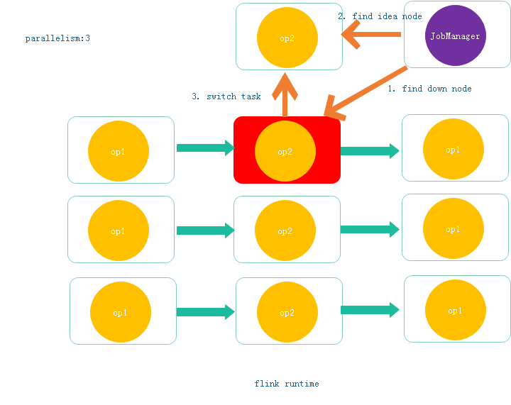

For micro service, if node is down, the service register center get status and notify the client, so that down node will not called again

